SUBSIDIARY ICT PAPER ONE 2013

- (a) Define Information and Communication Technology (1mark)
………………………………………………………………………………………………………………………………………………………………………………………………………………………………………………………………………………..
(b) Assuming, you have been appointed as the head of ICT department in your school. The school wishes to buy new computers to ease the work of teaching and learning ICT.
Explain four factors you would consider when buying computers.
(4 marks)

………………………………………………………………………………………………………………………………………………………………………………………………………………………………………………………
………………………………………………………………………………………………………………………………………………………………………………………………………………………………………………………
………………………………………………………………………………………………………………………………………………………………………………………………………………………………………………………
- Explain one specialised application ICTs can play in each of the following areas (5 marks)

- Education
…………………………………………………………………………………………………………………………………………………………………………………………………………………………………………………………………………………………………………………………………………

- Health

…………………………………………………………………………………………………………………………………………………………………………………………………………………………………………………………………………………………………………………………………………
- Entertainment
…………………………………………………………………………………………………………………………………………………………………………………………………………………………………………………………………………………………………………………………………………

- Security
…………………………………………………………………………………………………………………………………………………………………………………………………………………………………………………………………………………………………………………………………………
- Industries
…………………………………………………………………………………………………………………………………………………………………………………………………………………………………………………………………………………………………………………………………………
- Bridget is a lab assistant in kibisi sec school. She was requested to present a list of items she would use in her computer lab. Among the items she listed included a blower, antiglare screens, computer covers, air conditioners and surge protector.
Explain the importance of the each of the following ( 5 marks)

- Blower
…………………………………………………………………………………………………………………………………………………………………………………………………………………………………………………………………………………………………………………………………………
- Antiglare screens
…………………………………………………………………………………………………………………………………………………………………………………………………………………………………………………………………………………………………………………………………………
- Water proof covers
…………………………………………………………………………………………………………………………………………………………………………………………………………………………………………………………………………………………………………………………………………
- Gaseous fire extinguisher
…………………………………………………………………………………………………………………………………………………………………………………………………………………………………………………………………………………………………………………………………………
- Surge protector
…………………………………………………………………………………………………………………………………………………………………………………………………………………………………………………………………………………………………………………………………………

- (a) In reference to the following file path: C/user/desktop/Abu/letter.doc. identify the following, (2marks)
- File name………………………………………………………
- File type……………………………………………………….
- Profile………………………………………………………….
- Folder……………………………………………………….
- Location……………………………………………………

- Give the file extension of the following file types. ( 5 marks)

File type file extension

- Ms Word …………………………………….
- Batch file …………………………………….
- Executable file …………………………………………
- Text file ………………………………………….
- Ms Excel ………………………………………….

- (a) Define peripheral devices (2marks)
…………………………………………………………………………………………………………………………………………………………………………………………………………………………………………………………………………………………………………………………………………
(b) A student wishes to store data on optical storage medium.
i) List down one optical storage medium (1 mark)

…………………………………………………………………………………

ii) Give one advantage of optical storage you have mentioned in b (i) above (1 mark)
……………………………………………………………………………………………………………………………………………………………………
iii) Give one disadvantage of optical storage you have mentioned in b (i) above (1 mark)
……………………………………………………………………………………………………………………………………………………………………

7. a) What is a hardware device? ( 2 marks)
…………………………………………………………………………………………………………………………………………………………………………………………………………………………………………………………………………………………………………………………………………

b) state one function of each of the following components of the computer central processing unit ( 3 marks)
(i) The control unit (CU)
…………………………………………………………………………………………………………………………………………………………
(ii) The arithmetic/logic unit (ALU),
…………………………………………………………………………………………………………………………………………………………
(iii) The Registers
…………………………………………………………………………………………………………………………………………………………

8. Name the devices A, B, C , D and E using the words from the list.

A B
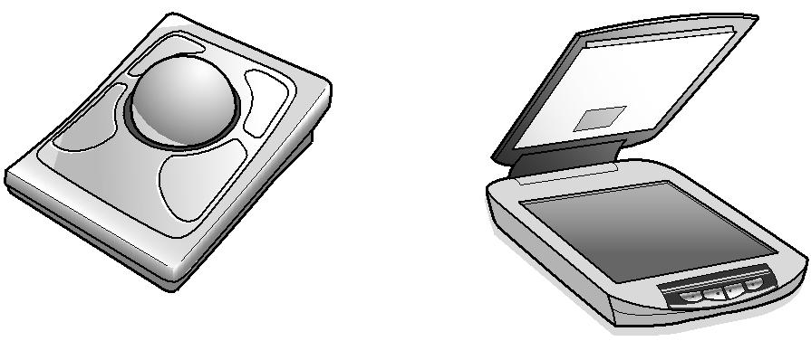

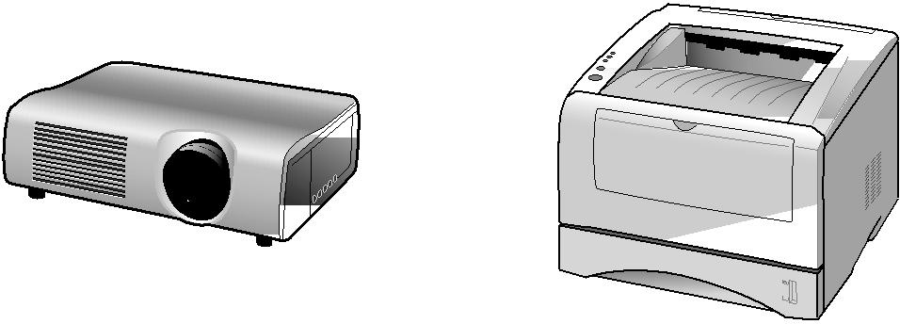
C D E
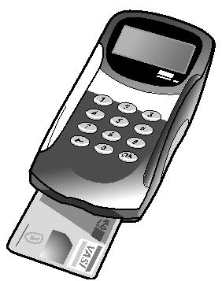

Data projector | Digital camera | Joystick | Laser printer
Microphone | Remote control | Scanner | Trackerball
A ………….............. |  | B…………………….
C…………………….. | .. | D……………………

E………………………..

9. Complete each sentence seen below using one item from list;
Compilers Interpreters linkers
Basic Cobol Custom software
Freeware Publication Packaged software

a) ………………………….. is a commercial software which is copyrighted and designed to meet the needs of many users. ( 1 mark)

b)………………………… is software provided at no cost to users. (1 mark)

c)……………………………..is software developed at a user request to perform specific function. (1 mark)

d)……………………………. Is software that translates the source program line by line while the program is running. (1 mark)

e) …………………………….is software that is used to teach junior programmers. (1 mark)

10. (a) What is operating system? (2 marks)
…………………………………………………………………………………………………………………………………………………………………………………………………………………………………………………………………………………………………………………………………………

(b)Explain any three functions of operating systems (3marks)

…………………………………………………………………………………………………………………………………………………………………………………………………………………………………………………………………………………………………………………………………………
…………………………………………………………………………………………………………………………………………………………………………………………………………………………………………………………………………………………………………………………………………

11. A student in school X was asked to format a flash disk in windows based operating system. The student instead formatted the hard disk by mistake.
(a) Explain the term formatting a disk ( 2 marks)
…………………………………………………………………………………………………………………………………………………………………………………………………………………………………………………………………………………………………………………………………………

(b) State three situations when the computer user will be required to format a disk (3 marks)
…………………………………………………………………………………………………………………………………………………………………………………………………………………………………………………………………………………………………………………………………………

12. Study the URL and answer the questions that follow:
http://www.ecdl.org/countries/uganda

(i) What does http stands for? (1 Mark)
…………………………………………………………………………………………..

…………………………………………………………………………………………..
(ii) The domain name is (1 Mark)

…………………………………………………………………………………………..

(iii) Which is the top-level domain (TLD) in this URL? (1 Mark)

…………………………………………………………………………………………..

(iv) What does “countries” represent in this URL? (1 Mark)
…………………………………………………………………………………………..

………………………………………………………………………………………….
(V) What is the document name which is currently opened on this website? (1 Mark)
…………………………………………………………………………………………..

…………………………………………………………………………………………..

13. Today internet is becoming almost part of man’s life. State any five positive effects of internet to the society. (5 marks)

…………………………………………………………………………………………………………………………………………………………………………………………………………………………………………………………………………………………………………………………………………
…………………………………………………………………………………………………………………………………………………………………………………………………………………………………………………………………………………………………………………………………………
……………………………………………………………………………………………………………………………………………………………………

14. a) a) explain the term Domain Name system (1 mark)
………………………………………………………………………………………………………………………………………………………………………………………………………………………………………………………..
An e-mail address is given as lubakyoya@gmail.com, identify each part of this address. (4marks)

- lubakyoya…………………………………………………………………
- @................................................................................................................
- Gmail……………………………………………………………………..
- .com………………………………………………………………………

15. (a) Define the concept of data communication ( 1 mark)
…………………………………………………………………………………………………………………………………………………………………………………………………………………………………………………………………………………………………………………………………………
(b) Explain the function of the each of the following in relation to data communication
a) Sending device ( 1 mark)
………………………………………………………………………………………………………………………………………………………..
b) Communication device ( 1 mark)
………………………………………………………………………………………………………………………………………………………..
c) Communication channel ( 1 mark)
………………………………………………………………………………………………………………………………………………………..
d) Receiving device ( 1 mak)
………………………………………………………………………………………………………………………………………………………..

16. Mobile telephones are used for accessing internet

- Give three advantages of using mobile telephones for internet access.( 3 marks)
…………………………………………………………………………………………………………………………………………………………………………………………………………………………………………………………………………………………………………………………………………
…………………………………………………………………………………………………………………………………………………………………………………………………………………………………………………………………………………………………………………………………………
- Give two disadvantages of using mobile telephones for internet access. ( 2 marks)
………………………………………………………………………………………………………………………………………………………………………………………………………………………………………………………………………………………………………………………………………………………………………………………………………………
17. ( a) define the term firewall as used in computing? ( 2 marks)
…………………………………………………………………………………………………………………………………………………………………………………………………………………………………………………………………………………………………………………………………………
(b) Mention any three forms of unauthorised access ( 3 marks)
…………………………………………………………………………………………………………………………………………………………………………………………………………………………………………………………………………………………………………………………………………

18. a) Briefly describe the concept of “green computing” ( 2 marks)

…………………………………………………………………………………………………………………………………………………………

(b) State any three advantages of green computing (2 marks)

……………………………………………………………………………………………………………………………………………………………………………………………………………………………………..
……………………………………………………………………………

19. The following is a mark sheet of senior four ngoma secondary school.

 | A | B | C | D | E
1 | NAMES | History | ICT | chemistry | art
2 | kabanda | 45 | 67 | 76 | 89
3 | kainembabazi | 34 | 45 | 56 | 48
4 | awori | 67 | 65 | 76 | 78
5 | mwondha | 98 | 56 | 45 | 59
6 | nyakato | 45 | 90 | 67 | 67

- Write a formula to calculate the following ( 3 marks)

- Total marks for Kabanda………………………………………

- Average score for Awori……………………………………….

- The highest score for Nyakato…………………………………

- Write a formula to count all the ICT students with marks greater than 60. ( 2 marks)
………………………………………………………………………

20. Lady Aisha book library uses a database to store information about the different books they have. Part of database is shown below.

Book Title | Number of books borrowed | Nature of the book cover Hard or Soft
Introduction to biology | 56 | Yes
Dictionaries | 52 | No
Uganda constitution | 38 | No
Encyclopedia | 35 | Yes

- (i) Which field in the table above stores Boolean data type? ( 1 mark)

………………………………………………………………..

(ii)Give a reason Why Boolean data type is used ( 1 mark)

…………………………………………………………………………………

…………………………………………………………………………………

- (i)Which field stores numeric data? ( 1 mark)

………………………………………………………………………………….

(ii) Give a reason Why Numeric data type is used ( 1 mark)

…………………………………………………………………………………

…………………………………………………………………………………..

- Suggest one other data type used in the database above. ( 1 mark)

……………………………………………………………………………….

END

